Tab 1

Emotion Detection Using Facial Landmarks

Alexander Nicholas, Kieran Hawkins, Michael Duggan
College of Science, Technology, Engineering, and Mathematics
CS 471: Artificial Intelligence
Dr. Sreedevi Gutta
May 9th, 2025

Table of Contents
Table of Contents 2
Introduction 3
Motivation 3
Prior research 3
Goals 4
Data 4
Dataset 4
Preprocessing 5
Data Cleaning 5
Feature Engineering 5
Exploratory Data Analysis 7
Data Distribution Charts 7
Feature Correlation Heatmap 8
Models and Experiments 9
Metric to Focus On 9
Decision Tree 9
Support Vector Machine 10
Multilayer Perceptron 11
Experiments 12
Predicting on Training vs. Validation vs. Test 12
Raw 12
Scaling 13
SMOTE (Synthetic Minority Over-sampling Technique) 14
Feature Selection Top 10 16
Hyperparameter Tuning 17
Conclusion 19
Model Comparison 19
Result Analysis 20
Member Contribution 21
Colab Link 22
References 22

Introduction

Motivation
We aim to develop a lightweight system for classifying facial expressions into seven distinct emotion categories using facial landmarks extracted from images. This task is important because facial expression recognition plays a critical role in human-computer interaction, security systems, and mental health monitoring. While deep learning methods dominate this space, they are computationally expensive. A simpler, fast, and explainable approach is needed, especially for devices with limited computational resources. Our challenge is to accurately classify human emotions using more traditional machine learning models and engineered features from facial landmarks.

Prior research
One example of prior research in this area that we found was the 2020 paper Facial Expression Recognition with Deep Learning from Stanford, which trained various Convolutional Neural Networks (CNN’s) on the FER-2013 dataset, which contains about 30,000 images of facial expressions divided into 7 classes. While they did manage to achieve 75.8% test accuracy using an ensemble of CNN’s models, we wanted to experiment with more traditional or lightweight models, rather than large Deep Learning models such as CNN’s.

Goals
Our primary goal was to achieve high test accuracy on classifying facial expressions from our dataset using lightweight, low-complexity models. We planned to tune the hyperparameters of those models using GridSearchCV and Optuna to optimize their performance. We decided to address any significant class imbalances in our dataset using SMOTE. Finally, we aimed to provide clear interpretability of our model’s decisions through visualizations and metrics like F1 score.

Data

Dataset
The Extended Cohn-Kanade or CK+ dataset is a widely used benchmark in facial expression recognition made up of around peak expression images extracted from video sequences of 123 subjects. Each image is labeled with one of seven emotions: anger, contempt, disgust, fear, happiness, sadness, and surprise. The dataset does have some variation in what you can find online as the original distributors of the dataset no longer distribute it. The dataset is imbalanced, with emotions like surprise and happiness appearing more frequently than underrepresented classes such as contempt and fear. The images themselves were captured in a controlled setting, this allows for extremely clean data but also unfortunately limited in real-world data variability. We split the dataset into 70/15/15 train/validation/test split with stratified sampling to hold class distribution. While the dataset's quality and annotations make it ideal for prototyping, its small size required us to apply class balancing techniques and evaluate models carefully.

Preprocessing

Data Cleaning
- Removed incomplete samples where facial landmark detection failed.
- Parsed tuple strings containing (x, y) coordinates into separate numeric float values.
- Extracted coordinate axes (usually x or y) depending on the geometry being computed for each feature.
- Dropped malformed or mislabeled rows, ensuring only the seven target emotion labels were present.
- Validated label integrity by confirming that each emotion label matched the CK+.
- Applied feature scaling to standardize feature ranges for models like SVM and MLP.
- Verified feature data types to ensure all engineered features were numerical and suitable for model input.

Feature Engineering
We engineered a set of 25 features from the raw (x, y) landmark coordinates extracted by MediaPipe Face Mesh. The features fall into four main categories: distances, angles, ratios, and symmetry:
- Distance features were calculated using the Euclidean distance formula between pairs of relevant landmarks.
  - All distance-based features were normalized using the inter-ocular distance.
- Angle calculated with arctangent function to measure the direction or slant of facial lines.
- Ratio features show proportions such as height-to-width, which help normalize individual facial differences while capturing expression intensity.
- Symmetry features were calculated as the absolute differences in horizontal position between symmetrical facial landmarks across the midline.
Feature Name | Category | Description / Formula | Landmark Pairs / Notes
left_eye_width | Distance | Distance between outer and inner corners of left eye | 33 – 133
left_eye_height | Distance | Vertical distance between upper and lower eyelids (left) | 159 – 145
right_eye_width | Distance | Distance between outer and inner corners of right eye | 362 – 263
right_eye_height | Distance | Vertical distance between upper and lower eyelids (right) | 386 – 374
left_eye_aspect_ratio | Ratio | left_eye_height / left_eye_width | Derived
right_eye_aspect_ratio | Ratio | right_eye_height / right_eye_width | Derived
left_eyebrow_eye_distance | Distance | Distance from left eyebrow to left eye | 105 – 33
right_eyebrow_eye_distance | Distance | Distance from right eyebrow to right eye | 334 – 263
inter_eyebrow_distance | Distance | Distance between inner eyebrow points | 65 – 295
mouth_width | Distance | Distance between left and right mouth corners | 61 – 291
mouth_height | Distance | Distance between upper and lower lips | 13 – 14
mouth_inner_width | Distance | Distance between inner mouth corners | 78 – 308
left_lip_height | Distance | Vertical distance on left side of lips | 61 – 146
right_lip_height | Distance | Vertical distance on right side of lips | 291 – 375
mouth_aspect_ratio | Ratio | mouth_height / mouth_width | Derived
nose_length | Distance | Length from bridge to tip of nose | 1 – 2
nose_to_lip_distance | Distance | Distance from nose tip to top lip | 2 – 13
jaw_width | Distance | Distance between jaw corners | 127 – 356
chin_to_nose_distance | Distance | Distance from chin to nose tip | 152 – 2
eye_line_angle | Angle | Angle between outer corners of the eyes | arctan2(y263 – y33, x263 – x33)
mouth_line_angle | Angle | Angle between mouth corners | arctan2(y291 – y61, x291 – x61)
eye_symmetry | Symmetry | |left_eye_width – right_eye_width| | Derived
mouth_symmetry | Symmetry | |left_lip_height – right_lip_height| | Derived
eyebrow_symmetry | Symmetry | |left_eyebrow_eye_distance – right_eyebrow_eye_distance| | Derived
facial_symmetry | Symmetry | Average symmetry across eyes, mouth, and brows | Composite feature

Exploratory Data Analysis

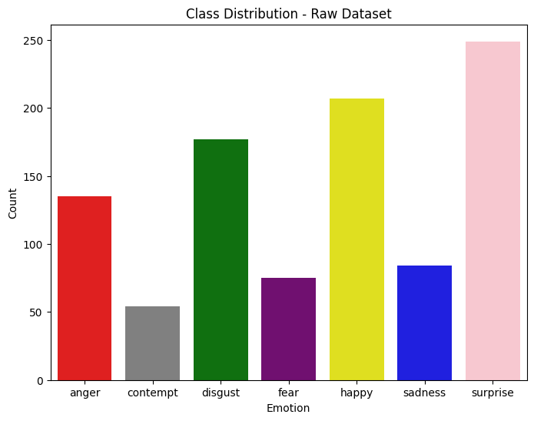
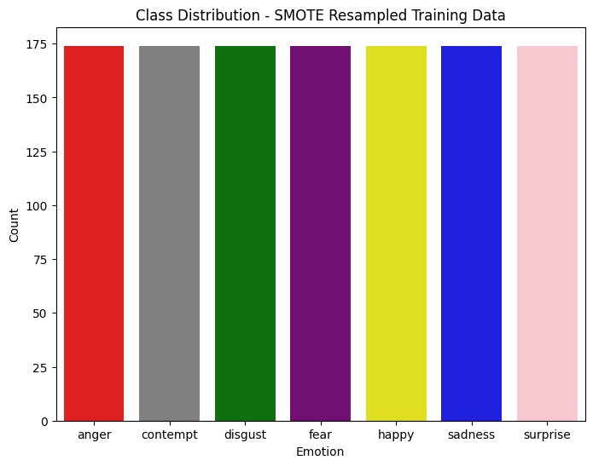
Data Distribution Charts
The first bar chart shows the raw class distribution in the CK+ dataset. The dataset is very imbalanced, with Surprise and Happiness accounting for a significant portion of the samples, while classes like Contempt and Fear are severely underrepresented. To address this issue, we applied SMOTE to the training set only. The second graph shows the effect of SMOTE: all of the emotion classes have been resampled to contain the same number of samples, ~175 samples, for each emotion. This ensures an even training data for each model allowing it to learn equally from each emotion and improve its ability to generalize across the emotion boundaries. This was a crucial step to prevent underfitting of rarer emotions.

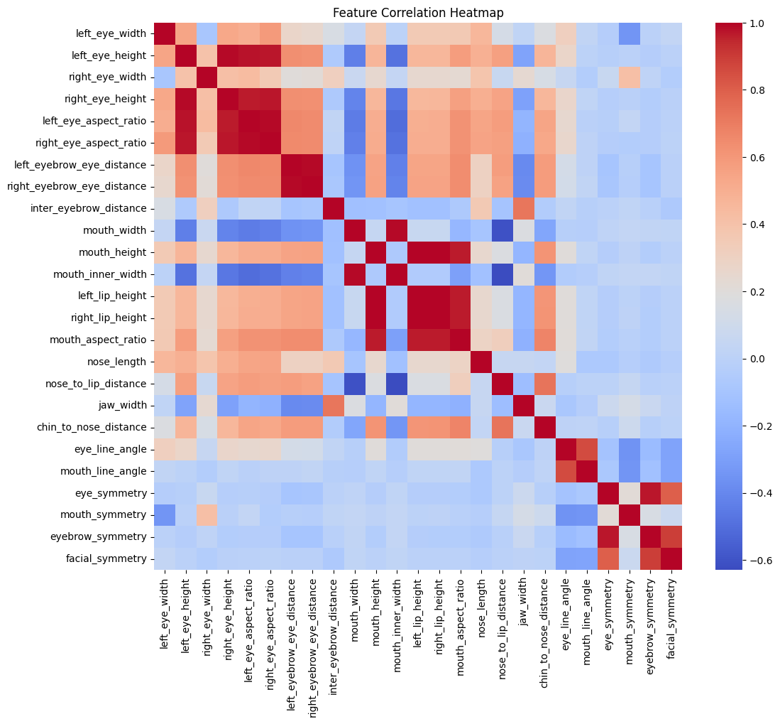
Feature Correlation Heatmap
The heat map above shows the correlation between all engineered features in our dataset. Values from -1(perfect negative) to +1(perfect positive), darker red being stronger positive and darker blue being stronger negative.
From this heatmap, we can see multiple strong relationships between mouth features, such as mouth_width, mouth_height, and mouth_inner_width. This makes sense, as they are geometrically related and often have correlated changes between expressions like smiling and frowning. On the other hand, some features have a weak correlation or none at all. An example being the symmetry features, such as mouth_symmetry, eye_symmetry, and facial_symmetry, and certain angles, such as eye_line_angle and mouth_line_angle. We can derive from this that they may capture independent, complimentary information useful for classification.

Models and Experiments

Metric to Focus On
Before we get to the models, experiments, and results, it is important that we talk about the primary evaluation metric we have chosen for this project and why. We decided to focus on F1-score for this project rather than rely solely on accuracy because of the unbalanced nature of the CK+ dataset. Certain emotion classes, such as Surprise and Happiness, had significantly more samples than others like Contempt or Fear. In such instances metrics such as accuracy could provide a biased and misleading view of model performance. A classifier that simply predicts the majority class can achieve a high accuracy while failing to correctly identify minority classes. The F1-score provides a balanced mixture of precision and recall, offering a more balanced assessment by taking into the consideration the model's ability to identify true positives(recall) and avoid false positives(precision). This is incredibly important for multi-class classifications like ours where the individual performance of each class is more important than the whole.

Decision Tree
A decision tree classifier is a machine learning algorithm for classification. In our project, we used Grid Search CV to make the decision tree to tune the hyperparameters. The decision tree was also used to make the predicted features.

Pros:
- Simple and interpretable
- Handles non-linear relationships
Cons:
- Likely to overfit if not restricted
- Can dramatically change from small changes
- Bias towards dominant classes

Support Vector Machine
A SVM or Support Vector Machine is a supervised learning algorithm and can be implemented in binary and multi-class classification problems. For our project we implemented a SVC or Support Vector Classifier from scikit-learn. This is a good fit for our project for one SVMs can be effective on smaller datasets such as CK+ where others may struggle. Also facial expressions involve complex geometry that are not linearly separable, with careful tuning SVMs can handle non-linear data well which is essential to distinguishing between subtle differences in facial expressions.
Pros:
- SVMs work well in moderate-high dimensional features areas.
- RBF kernel captured non-linear relationships between facial features and emotion labels well.
- With good tuning can be strong against overfitting.
Cons:
- With a bigger dataset SVMs can be computationally expensive.
- Lacks a certain sense of interoperability in comparison to things like decision trees.
- While strong against overfitting with good tuning they are very parameter sensitive which could in return lead to bad overfitting or model degradation.

Multilayer Perceptron
While the goal of this project was to experiment with applying more traditional, lightweight Machine Learning models to facial features rather than larger Deep Learning models such as CNN’s, we also implemented a simple Multilayer Perceptron, or MLP. Similar to SVM’s, MLP’s are effective for nonlinear data, which is suitable for our project since facial emotions involve complex interactions between landmarks that may not be linearly separable. MLPs can also efficiently learn nonlinear relationships in high-dimensional spaces, such as relationships between many facial features.
Pros:
- Effective for Nonlinear Data: Facial emotions involve complex interactions between landmarks that may not be linearly separable.
- Effective for High-Dimensional Data: MLPs can efficiently learn nonlinear relationships in high-dimensional spaces.
- Versatile: MLP’s have proven to generalize well to small and large datasets.
Cons:
- Require a lot of data: MLPs typically require large datasets to perform well.
- Training complexity: Neural networks are more computationally expensive to train.
- Hyperparameter tuning: MLPs have more hyperparameters to tune.

Experiments

Predicting on Training vs. Validation vs. Test
In our project, we carefully separated the dataset into three distinct subsets: training, validation, and test sets. The training set was used to fit the models and learn the patterns. The validation set was used during hyperparameter tuning to evaluate how well the model generalizes to unseen data while still allowing iterative improvements. Finally, the test set was kept separate and only used for final evaluation, ensuring an unbiased estimate of “real-world” performance.

Raw
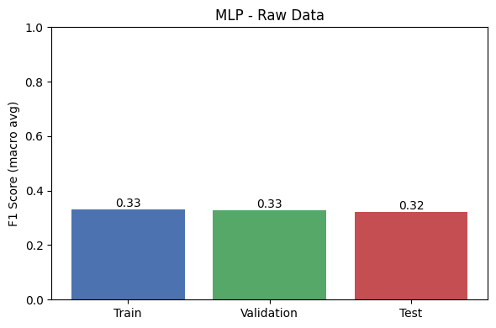
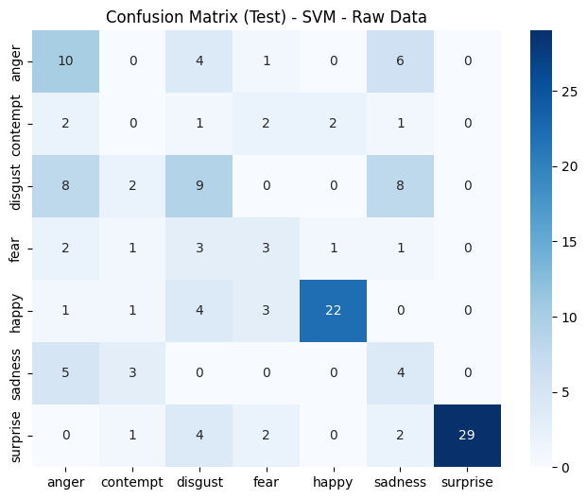
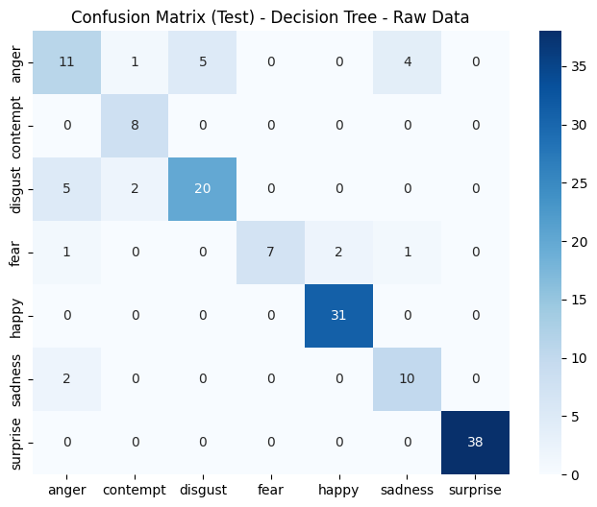
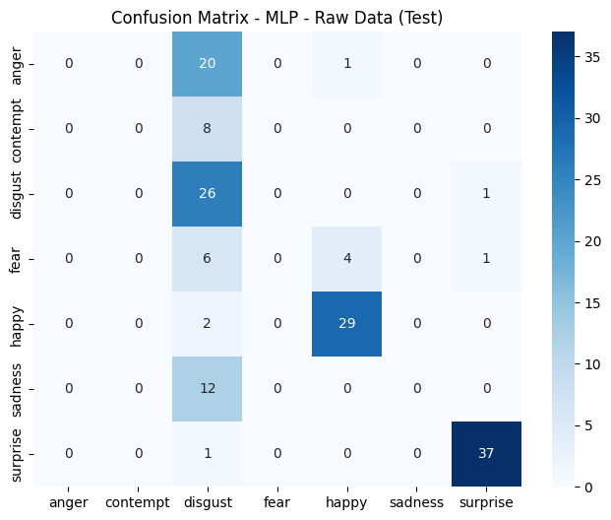
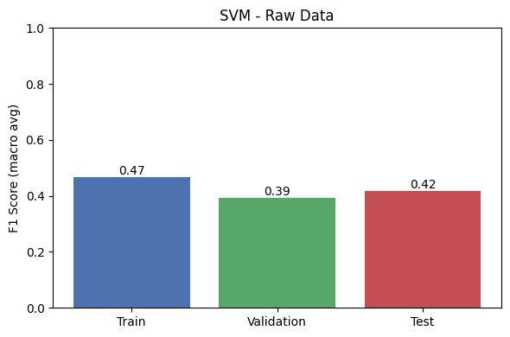
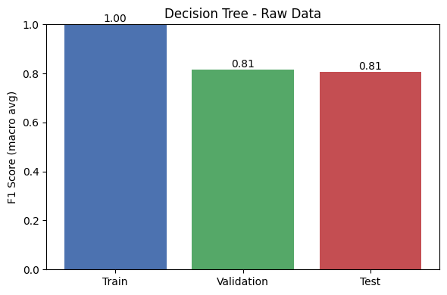
Each model was trained and tested on the raw feature set without any scaling, balancing, or feature selection.
- Decision Tree performed the best in this setting, with a test F1-score of 0.81, despite clear signs of overfitting (train F1 = 1.0).
- SVM underperformed with a test F1-score of 0.42, struggling with class imbalance and inconsistent scaling.
- MLP showed the poorest generalization, with a test F1-score of just 0.32, often defaulting to dominant class predictions and failing on minority classes like fear and sadness.

Scaling
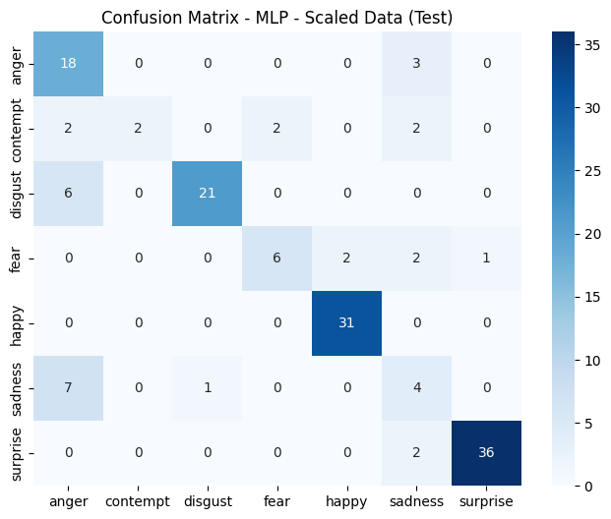
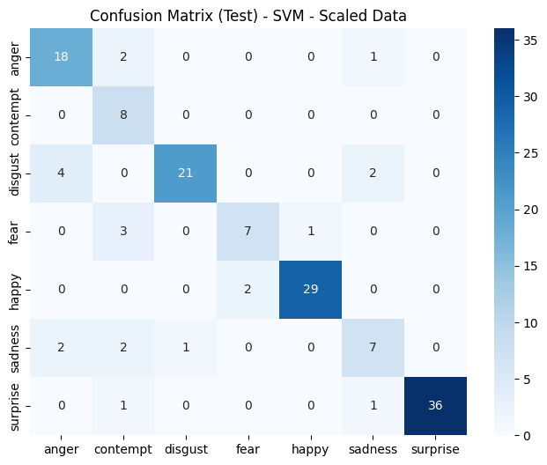
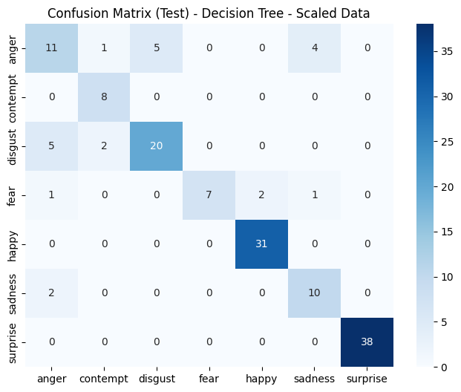
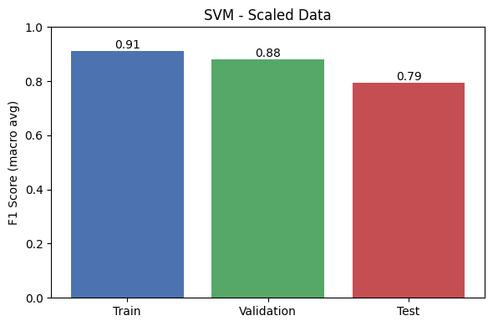
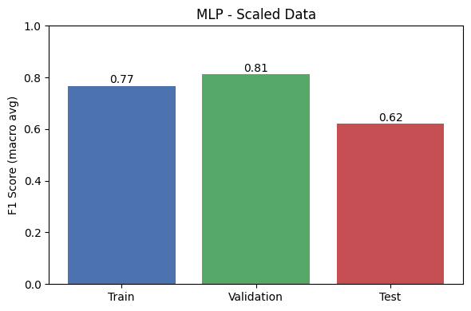
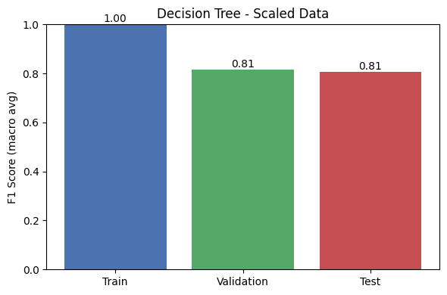
1. Decision Tree (Scaling)
- Train F1 (both raw & scaled): 1.00 -> Clear overfitting.
- Validation/Test F1: ~0.81/0.81 -> Minimal change with scaling.
- Interpretation: Decision Trees are scale-invariant, so scaling has no meaningful effect.
2. SVM (Scaling)
- Train/Validation/Test F: Train: 0.47 -> 0.91/Validation: 0.39 -> 0.88/Test: 0.42 -> 0.79
- Key Gains: Class predictions became more accurate and balanced. Surprise, happiness, and disgust all benefited. Fewer false positives across all classes.
- Interpretation: Scaling ensures uniform feature influence and leads to better margin calculation and kernel similarity.
3. MLP (Scaling)
- Train/Validation/Test F: Train: 0.33 -> 0.77/Validation: 0.33 -> 0.81/Test: 0.32 -> 0.62
- Observation: MLP training stabilized significantly with scaling. This makes sense since MLPs use gradient descent, which is highly affected by inconsistent input ranges.

SMOTE (Synthetic Minority Over-sampling Technique)
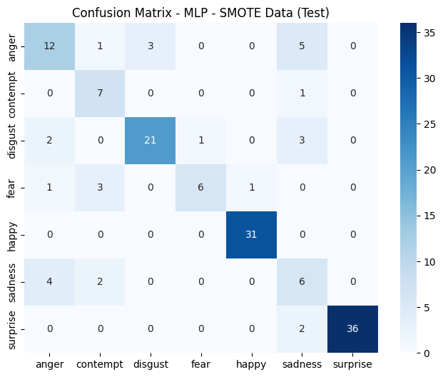
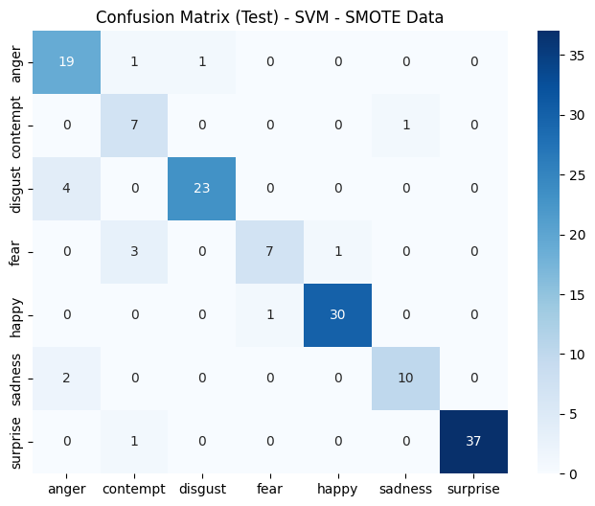
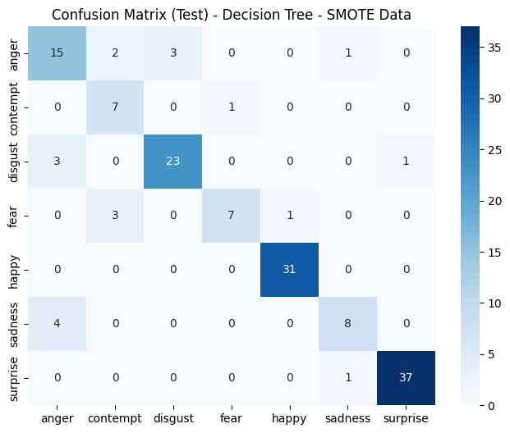
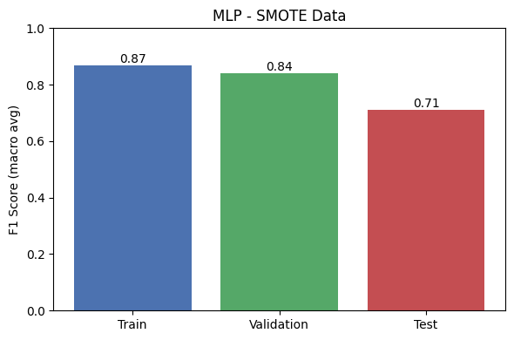
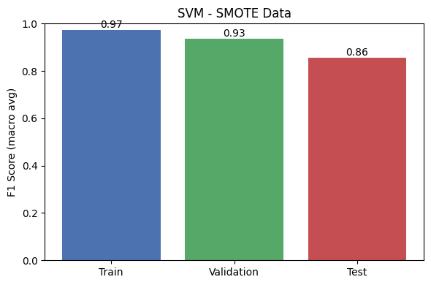
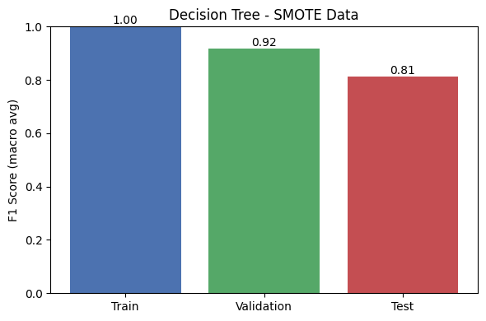
1. Decision Tree (SMOTE)
- Train/Validation/Test F: Train: 1.00/Validation: 0.81 -> 0.92/Test: 0.81
- Corrected earlier bias toward dominant classes (Happy, Surprise).
- More balanced confusion matrix, especially for Fear, Disgust, and Sadness.
- Tree memorized training set perfectly (common for unpruned trees).
2. Support Vector Machine (SMOTE)
- Train/Validation/Test F: Train: 0.91 -> 0.97/Validation: 0.88 -> 0.93/Test: 0.79 -> 0.86
- Balanced precision and recall across all 7 emotion classes.
- Maintained near-perfect accuracy on Happy, Surprise, Disgust.
- Significant gains in Contempt and Fear accuracy post-SMOTE.
3. Multilayer Perceptron (SMOTE)
- Train/Validation/Test F: Train: 0.77 -> 0.87/Validation: 0.81 -> 0.84/Test: 0.62 -> 0.71
- Clear improvements over raw and scaled data experiments.
- Increased accuracy on previously neglected classes (Contempt, Anger).
- Boosted Disgust and Happy performance.
- Prone to class imbalance sensitivity despite SMOTE, likely due to overparameterization relative to dataset size.

Feature Selection Top 10
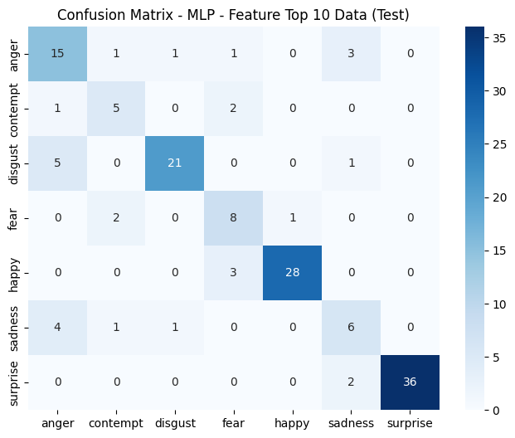
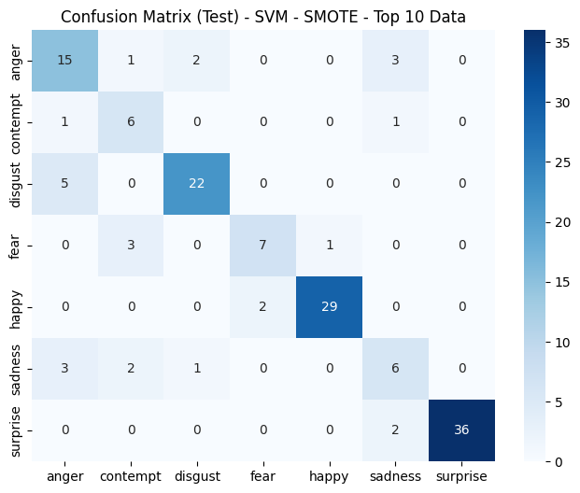
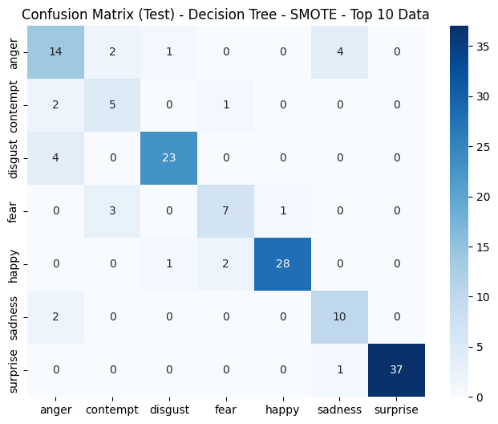
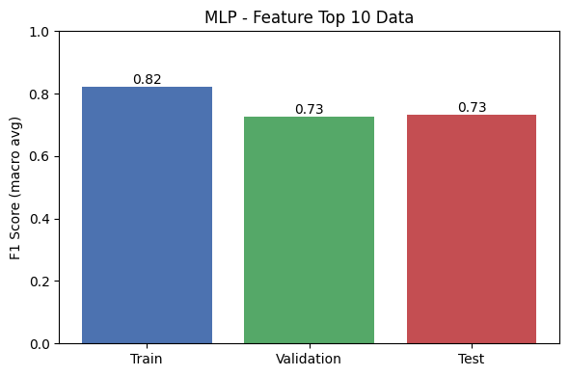
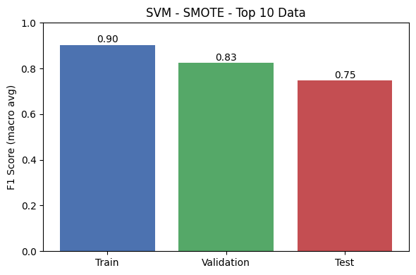
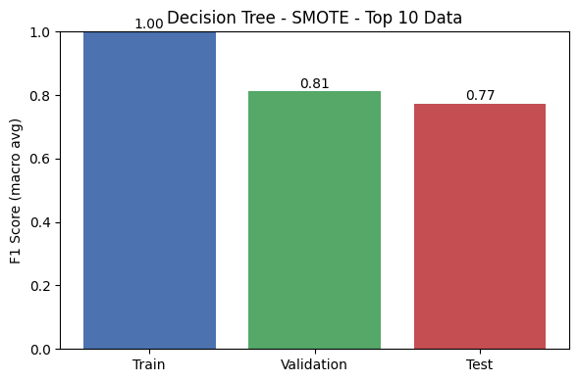
1. Decision Tree (Top 10)
- F1 dropped slightly from 0.81 -> 0.77.
- Performance remained consistent for Surprise and Happy, but Contempt and Anger misclassifications increased.
- Trees likely relied on additional, subtle features to separate overlapping expressions.
2. Support Vector Machine (Top 10)
- Performance dropped the most, from 0.86 -> 0.75 F1.
- Lost precision on Disgust, Sadness, and Contempt.
- SVM benefits from richer, high-dimensional feature sets that help define its separating hyperplanes.
3. Multilayer Perceptron (Top 10)
- Only model that improved from 0.71 -> 0.73 F1.
- Due to overfitting with the full feature set; reduced dimensionality provided regularization.
- Still struggled slightly with Fear and Sadness, but improved on Disgust and Surprise.

Hyperparameter Tuning
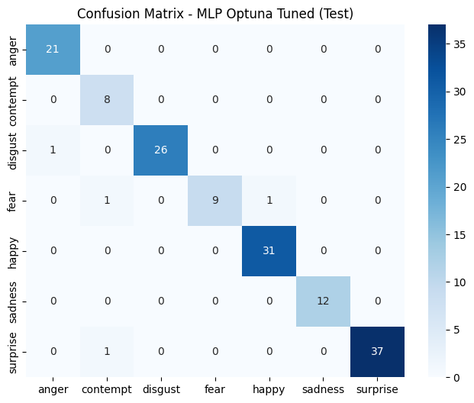
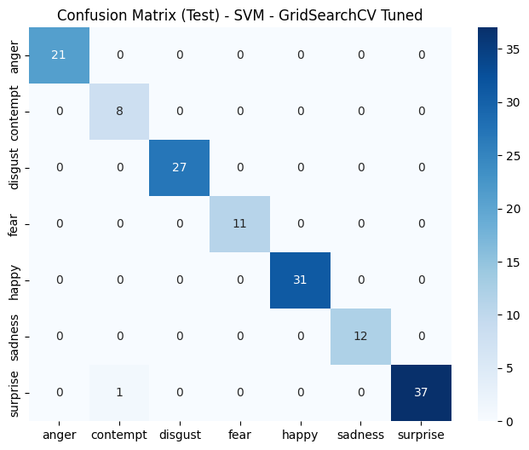
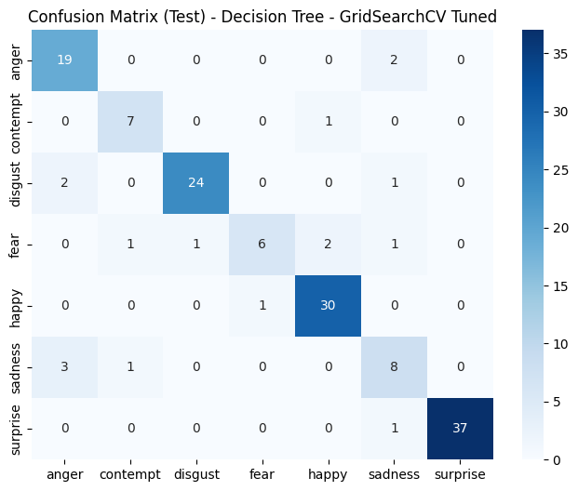
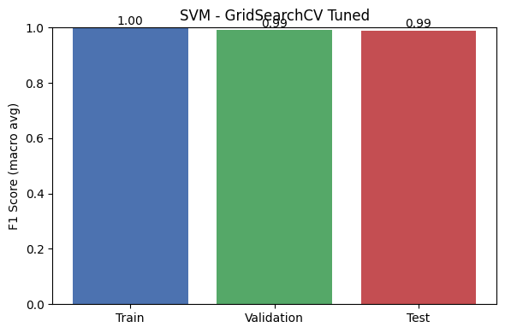
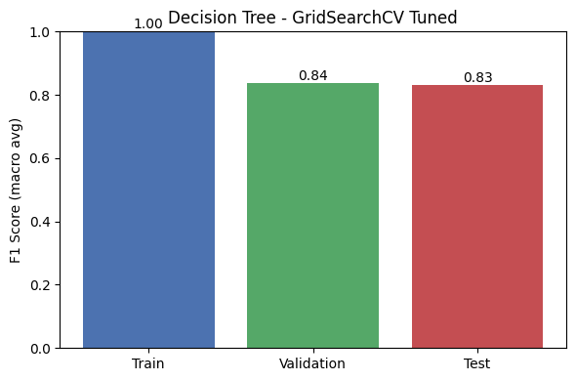
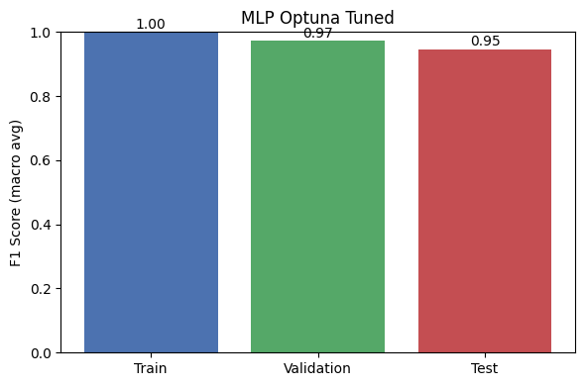
1. Decision Tree (Tuned)
Decision Tree improved slightly in macro F1 compared to earlier SMOTE versions. It still shows signs of overfitting, especially on the training set (F1 = 1.00), and some confusion remained between Fear and Happy, and Sadness and Anger.
- GridSearchCV over criterion, splitter, and max_depth.
- Best: {'criterion': 'entropy', 'max_depth': 10, 'splitter': 'best'}.
2. SVM (Tuned)
SVM ended up as the best-performing model post-tuning, achieving perfect precision and recall on all classes except a few minor false positives. Its final test F1 score was 0.9897, demonstrating almost perfect generalization.
- GridSearchCV over kernel, C, and gamma.
- Best: {'kernel': 'rbf', 'C': 50, 'gamma': 'scale'}.
3. Multilayer Perceptron (Tuned)
MLP, with Optuna-tuning, saw great gains. It maintained high F1 scores across all classes, especially for Disgust, Happy, and Surprise, but still saw a minor drop in recall for Fear. It finished with a test F1 of 0.9468, making it competitive with SVM.
- Optuna tuned hidden_dim, dropout, learning_rate, weight_decay, and batch_size.
- Best: 1 hidden layer, 49 neurons, dropout_p = 0.29, lr = 0.0076, weight_decay = 0.00013.(subject to change)

Conclusion

Model Comparison
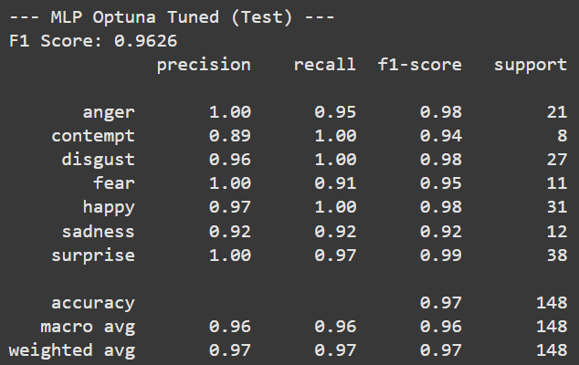
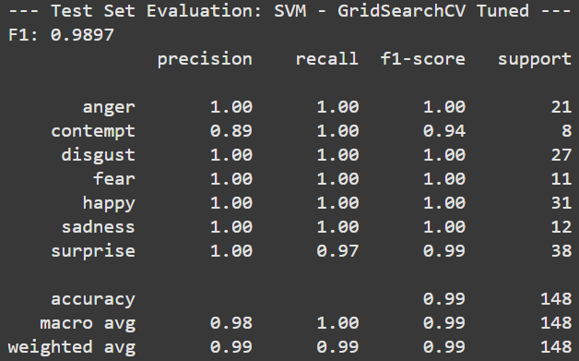
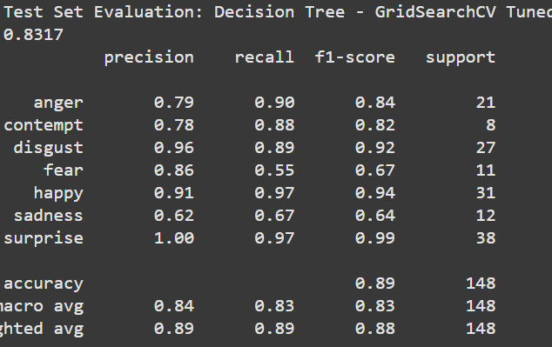
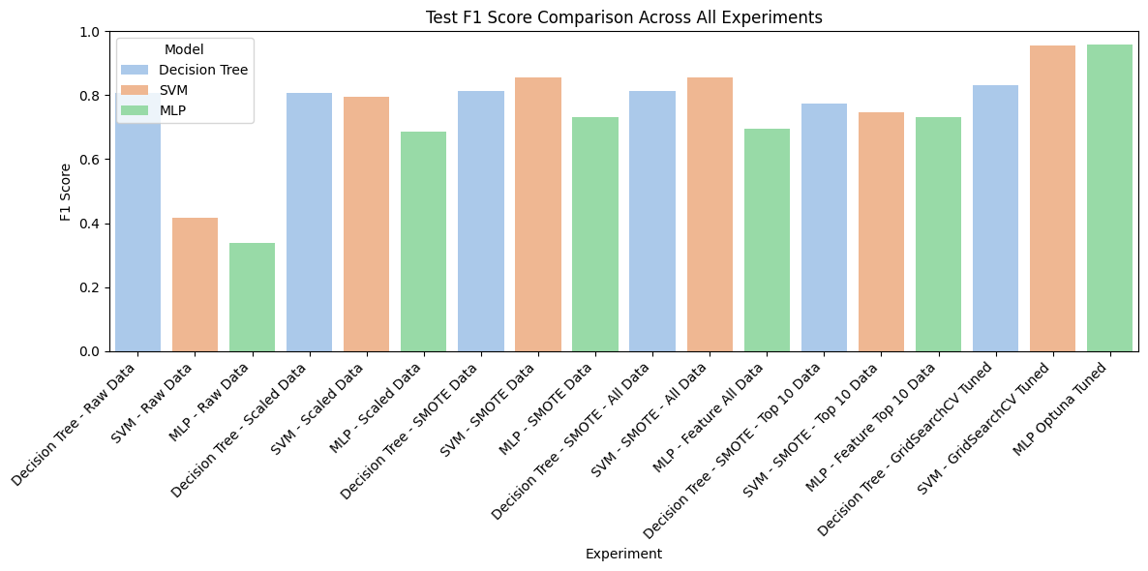

The primary metric we used to compare how well the models generalized to the test set was macro average F1 score, because it effectively represents the overall performance on all 7 emotion classes, and is also a more reliable metric than accuracy for an imbalanced dataset like CK+ where accuracy can be misleading. Accuracy is not a fair metric for such an imbalanced dataset because good performance on a few majority classes can create the illusion that the model is performing well overall, when it may be struggling at correctly predicting the minority classes. F1 score solves this issue by balancing precision and recall, making it more representative of the model’s performance across all classes.

Result Analysis
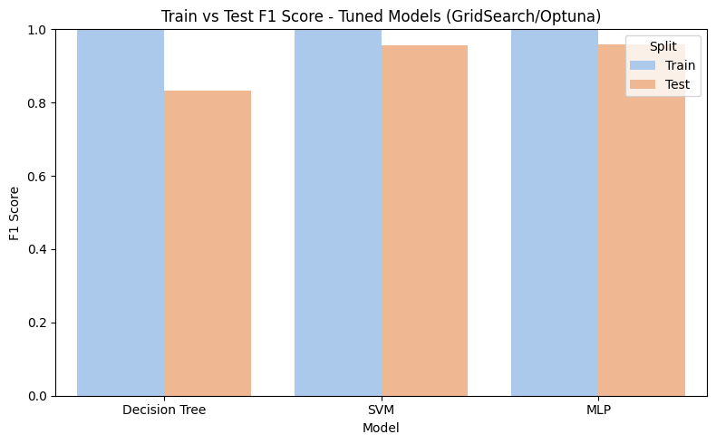
Out of the three models we tested, after hyperparameter tuning, the SVM had the highest macro average F1 score of 0.99 on the test set, with the MLP in second place at 0.95, and the Decision Tree at 0.83. All three of the models achieved perfect F1 scores on the train sets, which suggests they are almost certainly overfitting due to the small size of the dataset, which contained less than 700 train images. Although our goal was to focus on lightweight, low-complexity models, we were initially optimistic that the more complex MLP would outperform the others. However, at least for this application, that was not the case, and we were somewhat surprised to see how significantly the SVM was outperforming the other models during the initial testing. One theory we had about why the MLP was not performing as well as expected was that it’s simply too complex to effectively learn general patterns with this little data. Even smaller MLP architectures with very few layers may have so many parameters for this task that they can perfectly overfit to the training data in relatively few epochs, meaning they will generalize poorly to new data. This theory is supported by the fact that even the simpler Decision Tree and SVM achieved perfect scores on the train set, which means overfitting and poor generalization is inevitable for the MLP. One solution to this problem that would likely significantly improve the MLP’s ability to generalize would simply be to use a larger dataset, such as FER-2013, which is more suitable for Deep Learning tasks. However, we would then be deviating from our goal of achieving high accuracy using lower-complexity models, since this may also involve a much larger architecture to achieve optimal performance. Considering we have achieved a near-perfect score on the test set using the simpler SVM model, this goal was effectively fulfilled, which provides strong evidence that classifying facial expressions using facial landmarks is feasible through more traditional Machine Learning models, and is likely worth future exploration.

Member Contribution
Alexander Nicholas: Implemented the Support Vector Machine (SVM) in scikit learn and tuned Hyperparameters using GridSearchCV, report contributions, slide contributions, consolidated code, data visualization, and data/feature engineering.
Kieran Hawkins: Implemented the Multilayer Perceptron (MLP) in PyTorch and tuned Hyperparameters using Optuna, slide contributions, and report contributions.
Michael Duggan: Implemented the Decision Tree classifier program for the dataset, tuned hyperparameters with GridSearchCV, copied and pasted the results on the slides, and report contributions.

Colab Link
CS 471 Final Assignment

References
“Comprehensive Guide to Classification Models in Scikit-Learn.” GeeksforGeeks, GeeksforGeeks, 17 June 2024, www.geeksforgeeks.org/comprehensive-guide-to-classification-models-in-scikit-learn/.
Khanzada, Amil, Charles Bai, and Ferhat Turker Celepcikay. "Facial expression recognition with deep learning." arXiv preprint arXiv:2004.11823 (2020).
MediaPipe from Google https://ai.google.dev/edge/mediapipe/solutions/guide
CK+ Dataset https://www.kaggle.com/datasets/shuvoalok/ck-dataset/data

